9 COMMITTEE DISTRICTS IN NYS  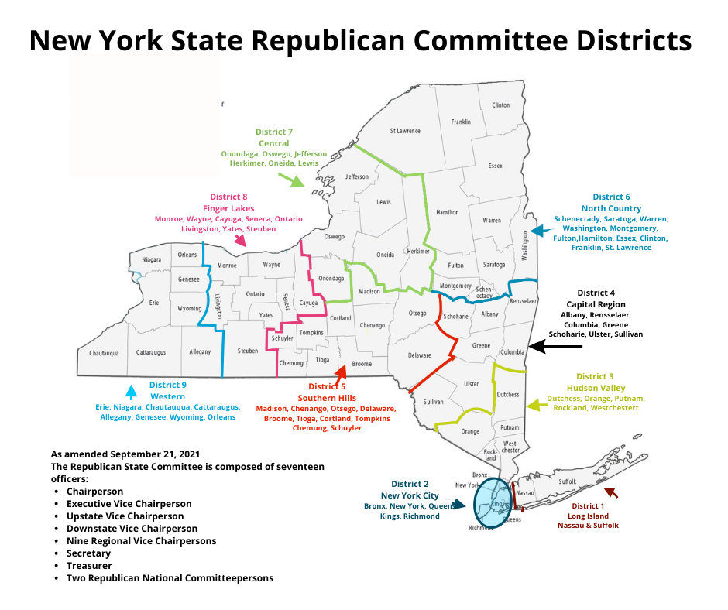  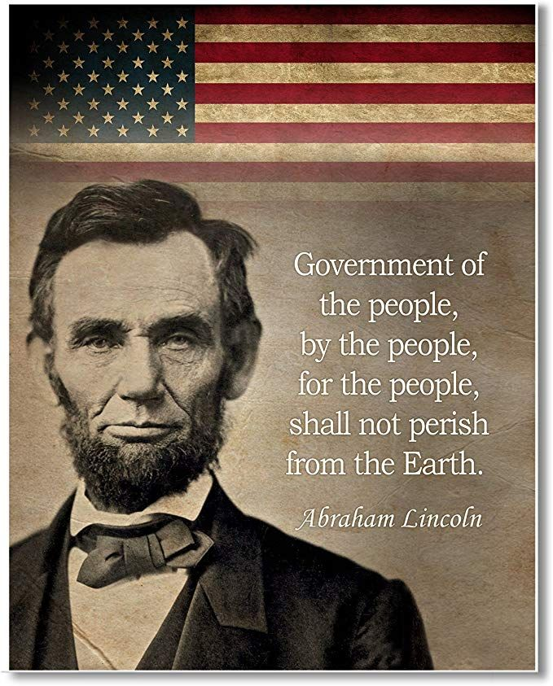 |  | EXAMPLE: SUFFOLK COUNTY, NY  MUNICIPALITY: TOWN OF BROOKHAVEN  ELECTION DISTRICT 187  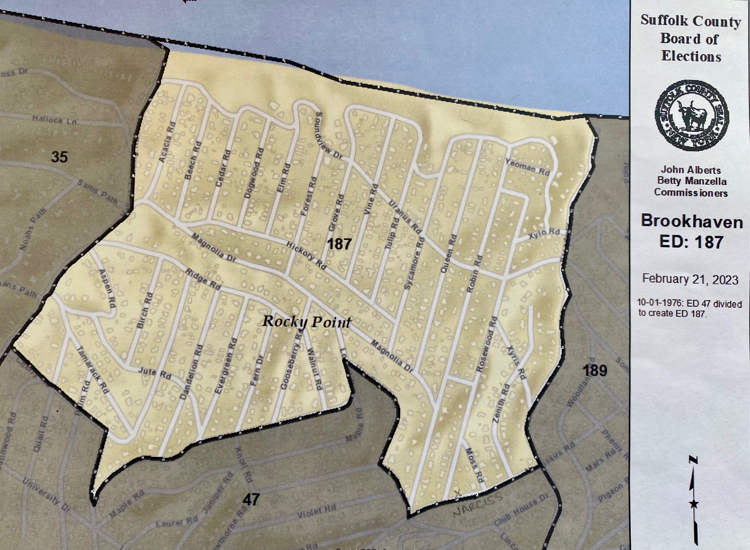  The Precinct Strategy is a grass roots effort  that encourages American citizens  to become politically active at the local level,  register to vote within a political party and  pursue committee membership within their county.  ● Question: Who decides what candidates appear on an election ballot?  ● Answer: Committee Members!  Go to precinctstrategy.us & .com or call/text (631)219-8529  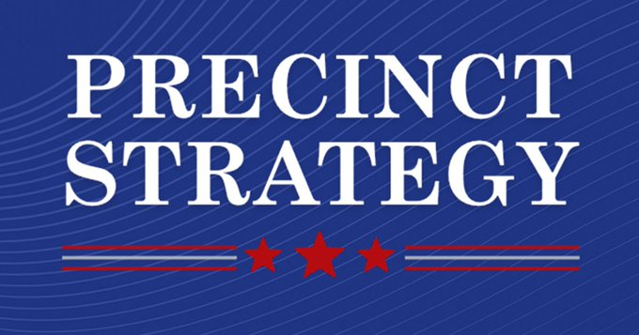

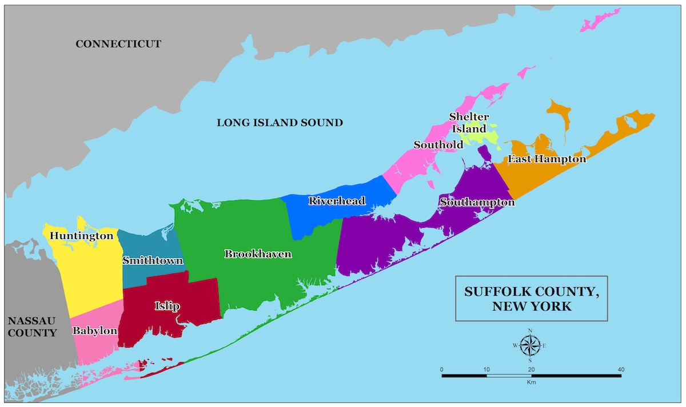  FIND YOUR MUNICIPALITY AND ELECTION DISTRICT voterlookup.elections.ny.gov  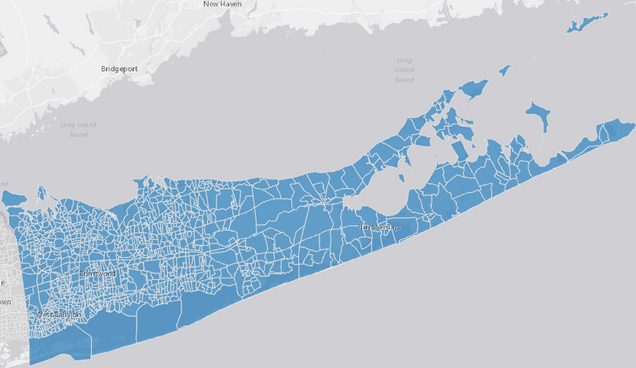  THERE ARE 10 MUNICIPALITIES CONTAINING  1,070 ELECTION DISTRICTS IN SUFFOLK COUNTY |  | DID YOU KNOW … ?  EVERY ELECTION DISTRICT  IS SUPPOSED TO HAVE  TWO (2) REPRESENTATIVES  WITHIN THE SUFFOLK COUNTY REPUBLICAN PARTY?  They are called “COMMITTEE MEMBERS”.  They are petitioned by registered voters  within their election district  And are empowered to nominate & elect  local candidates that appear on a ballot in an election  & party leaders who determine state/federal representatives.  This enables better representation!  This is how a  REPRESENTATIVE GOVERNMENT  is maintained throughout the 50 states!  BUT …  There are VACANCIES !!!  AND YOU could be a COMMITTEE MEMBER!  Get INVOLVED!  AND TAKE BACK (Y)OUR COUNTRY!!!  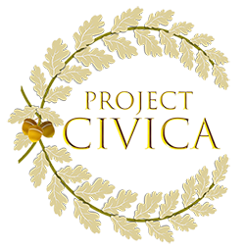  Go to projectcivica.org or call/text (716) 309-5062

